Phase 4: Beyond Padlocks

Main objectives and issues
For the teacher
- Present real-life situations and problems where counting strategies found with padlocks are also useful.
- Homogenize levels, helping those students who may have fallen further behind, offering individual work.
For students
- Work individually with counting problems in situations outside of padlocks.
- Evolving strategies: from padlocks to counting problems.
- Assess which of the proposed strategies is most efficient and economical according to the problem presented.

Phase structure: main moments, timing and classroom dynamics

[1] Work with combinatorics problems 120 min (Work at home and in the classroom)
In this stage, closer to traditional problem work, typical counting problem situations are presented. The list of problems presents different situations where students must choose the appropriate counting technique.
The teacher can solve the first cases with the students as an example and let them, individually, continue to complete the list .
The teacher can propose the following questions as a possible strategy for addressing the problems:
- Let's build an imaginary padlock, where the codes represent the different options that must be counted. What examples of codes could we build?
- In this imaginary padlock, does the order in which the elements are introduced matter? Can these elements be repeated?
- What are the numerical variables of this padlock (r,n)?
In the example in Figure 1 you can see how the example problem could be approached.
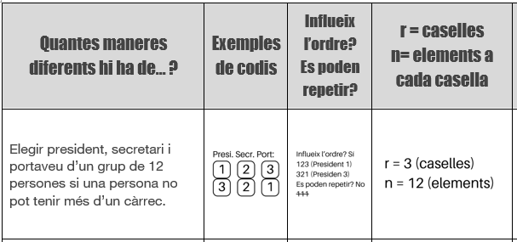
Figure 1 : Example of a problem-solving strategy
Based on this approach, students could recover their own resolution strategies or take advantage of the combinatorics scheme, with more economical calculation techniques to find the number of codes for each problem.
It is recommended to dedicate one session to autonomous and individual work, with guidance and help from the teacher, and ask students to complete this list as homework. Another session can also be dedicated to correcting and sharing the different problems.

Resources and materials needed/available
For teachers
For students
Document 09b - Phase 4_Combinatorics Problems with the list of combinatorics problems in table format.

Relevant comments for the management of Phase 2
It is important to make a good transition from the padlock situation to the general counting problems. The importance of working with padlocks must be constantly reminded in order to find the final strategies. The expressions “ order matters and they may or may not be repeated ” tend to be confusing if they are not understood well or the language is abused, so the proposed questions can be posed by referring to the imaginary padlock that represents the new problem.
Resisting...
Make immediate use of the combinatorics table if the student does not yet have a good understanding of what the expressions “ order matters” or “ can be repeated” mean .

